ssh pi@raspberrypi.local

nano wpa_supplicant.conf:
country=NL
ctrl_interface=DIR=/var/run/wpa_supplicant GROUP=netdev
update_config=1
network={
ssid="SSID"
psk="PASSWORD"
key_mgmt=WPA-PSK
}

Enabling SSH:
touch ssh
add this line to the end of boot/config.txt file:
dtoverlay=dwc2

add this text after rootwait with one space:
modules-load=dwc2,g_ether

sudo i2cdetect -y 1
sudo raspi-config (enable I2C in interfaces)

https://www.raspberrypi.com/documentation/computers/os.html
https://learn.sparkfun.com/tutorials/raspberry-gpio/all

sudo shutdown -h now

################ Rockpi N10 ##################
#gpio
https://wiki.radxa.com/RockpiN10/hardware/gpio
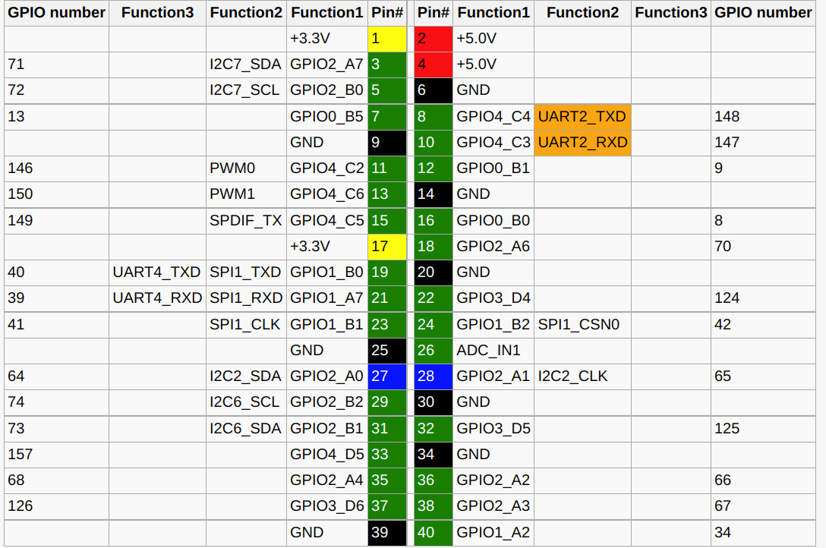
I used gpio number 157 which is pin 33 as output for signaling raspberry.

